**A Mini Project Report on**

**SMART IRRIGATION SYSTEM BY USING THINGSPEAK TECHNOLOGY**

**In Fulfilment of the Requirements for the Award of the Degree of**

**BACHELOR OF TECHNOLOGY**

**IN**

**ELECTRONICS AND COMMUNICATION ENGINEERING**

**Submittedby**

**K.PENCHALANARASAIAH 1610225**

**S.SWAMY NAIK 1610249**

**K.GANGA LAKSHMI 1610226**

**K.SREEVANI 1610264**

**A.VYSHNAVI 1610202**



**Under the esteemed Guidance of**

**Mr. D. PURUSHOTHAM REDDY, M.Tech.,**

**Lecturer, Department of Electronics and Communication Engineering**

**DEPARTMENT OF ELECTRONICS AND COMMUNICATION ENIGINEERING**

**COLLEGE OF ENGINEERING AND TECHNOLOGY**

**SRI KRISHNADEVARAYA UNIVERSITY**

**ANANTAPURAMU -515003**

**DEPARTMENT OF ELECTRONICS AND COMMUNICATION ENGINEERING**

**COLLEGE OF ENGINEERING AND TECHNOLOGY**

**SRI KRISHNADEVARAYA UNIVERSITY**

**ANANTAPURAMU – 515003**



**CERTIFICATE**

This is to certify that the project work entitled “**SMART IRRIGATION SYSTEM USING** **THINGSPEAK TECHNOLOGY**” is a Bonafied work of **K. PENCHALANARASAIAH (1610225),**

**S. SWAMY NAIK (1610249),** **K. GANGA LAKSHMI (1610226)**, **K. SREEVANI (1610264)**,

**A. VYSHNAVI (1610202)** submitted to the faculty of **ELECTRONICS AND**

**COMMUNICATION ENGINEERING** in fulfilment of the requirement for

the degree of bachelor of technology from college of engineering and technology

sri krishnadevaraya university, Ananthapur.

**Signature of the guide:** **Signature of the HOD:**

D.PURUSHOTHAM REDDY, M.tech., D.N. KULDEEP SHAMGAR, M.tech.,

Lecturer, Head of the Department,

Dept. of ECE, Dept. of ECE,

SKU College of Engg & Tech, SKU College of Engg & Tech,

Anantapur. Anantapur.

**DECLARATION**

We Student studying final year B.Tech, Dept. of **ELECTRONICS AND COMMUNICATION ENGINEERING, SRI KRISHNADEVARAYA** **UNIVERSITY COLLEGE OF ENGINEERING AND TECHNOLOGY**. We have registered for the final year Mini Project entitled “**SMART IRRIGATION SYSTEM BY USING** **THINGSPEAK TECHNOLOGY**” submitted for the B.Tech under the guidance of Mr **D.PURUSHOTHAM REDDY,** **M.Tech.,** and we promise to meet all the mandatory requirements as a specified by the project review committee. We declare that we will not hold the college, the department and the lecturers responsible for the out come of our project result.

Place: **Anantapur**  **Signature of the students:**

Date: 1.

2.

3.

4.

5.

**ACKNOWLEDGEMENT**

I wish to express my sincere gratitude to my project guide.

**Mr D.PURUSHOTHAM REDDY**, M.Tech., Lecturer, Department of Electronics and Communication Engineering, SKUCET, ANANTAPUR for his valuable guidance and supervision during the course of this work. Apart from the technical knowledge, I gained a lot of information from him, which will be useful in my career.

I wish to express my sincere gratitude to **Mr D.KULDEEP SHAMGAR** M.Tech, professor and Head of the Department, Department of Electronics and Communication Engineering, SKUCET, ANANTAPUR. for providing necessary facilities to carry out this project work.

I am also in debted to the entire faculty who has imparted considerable knowledge to me during my study at this institution.

Finally, I take this opportunity to express my profound sense of gratitude to my friends for the valuable suggestions, and other help provide.

**CONTENTS**

ABSTRACT

**Chapter-1: List of Figures and List of Tables (8)**

* 1. Circuit diagram
  2. ThingSpeak representation graphs

**Chapter-2: Basics of IOT (10)**

2.1 Definition

2.2 Introduction to IOT

2.3 What devices makes to IOT

2.4 Are Mobile Phones are IOT Devices

2.5 IOT Platform

2.6 Embedded Platform

**Chapter-3: Introduction of Hardware (14)**

3.1 NodeMCU

3.1.1 Introduction to NodeMCU

3.1.2 Pin diagram of NodeMCU

3.2 Soil Moisture Sensor

3.3 DHT11 Sensor

3.4 Submersible Water Pump

3.5 Relay Switch

**Chapter-4: Working Technology (22)**

4.1 IOT in proposed irrigation

4.2 Working thingSpeak

4.3 ThingSpeak setup

**Chapter-5: Result (24)**

5.1 output

5.2 Advantages

5.3 Applications

**Chapter-6: Conclusion & Future Scope (26)**

6.1 Conclusion

6.2 Future Scope

**ABSTRACT**

In IOT based smart farming, a system is built for monitoring the crop field with the help of sensors (humidity, temperature and soil moisture, etc.) and automating the irrigation system. The farmers can monitor the field conditions from anywhere. IOT based smart farming is highly efficient when compared with the conventional approach. By using Thingspeak technology we can monitor the crop fields from anywhere in the world with the help of Thingspeak ID. ThingSpeak is a web server, which can be used in user mobile with a thingSpeak user ID with Internet, And thus the farmer can monitor his farm from anywhere. Mostly used in indoor farming like mushroom cultivation by using DHT11 sensor, and also in agricultural farming by using Soil Moisture sensors. Sensors are connected to NodeMCU, it is an Electronic module interface and this is connected to internet through a ThingSpeak server.

**Chapter-1**

**1.1CircuitDiagram**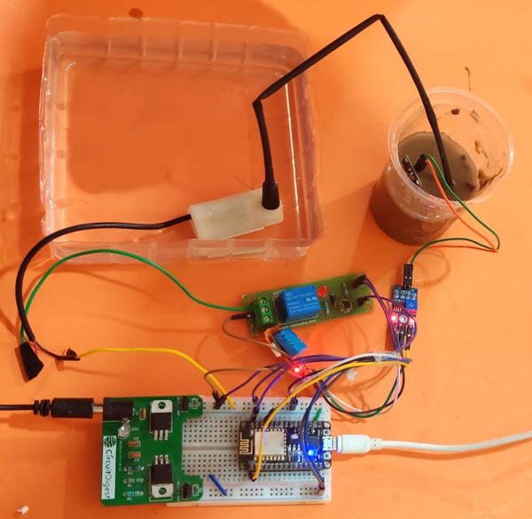 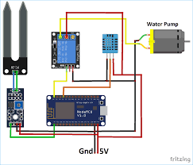

**Fig: block diagram**

**1.2 ThingSpeak representation graphs**

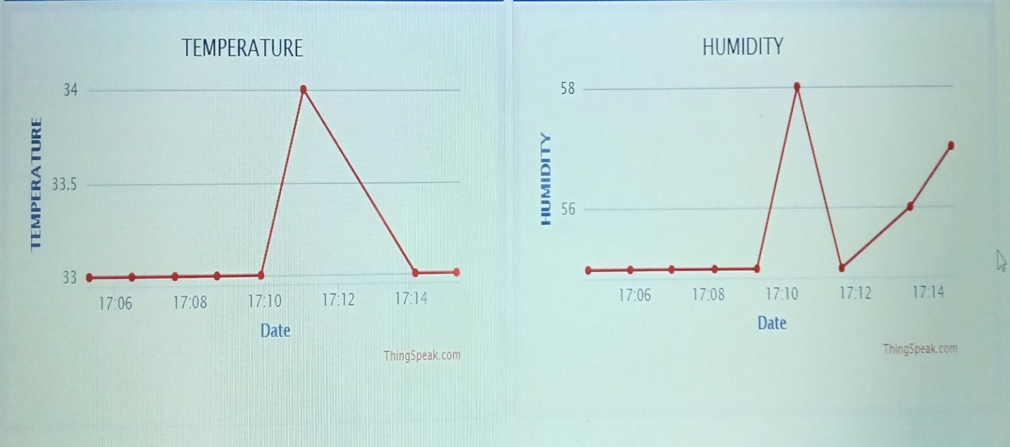

* This is the graphical representation of temperature and humidity present in a room.
* By using this visualization we can control the temperature and humidity present in that room.

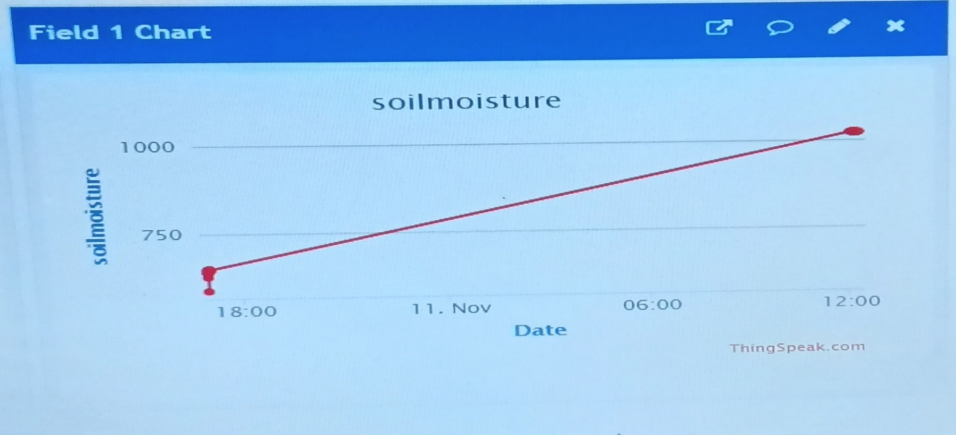

* This is the graphical representation of water level present in the soil.
* By observing this graph we can manage the water level in the field using waterpump.

**CHAPTER-2**

**BASICS OF IOT**

**2.1 DEFINITION:**

The Internet of Things (IoT) is the interconnection of uniquely identifiable embedded computing devices within the existing Internet infrastructure.

The “Internet of Things” connects devices and vehicles using electronic sensors and the Internet.

**2.2 Introduction to IOT:**

The Internet of Things (IoT) is the network of physical objects devices, vehicles, buildings and other items embedded with electronics, software, sensors, and network connectivity that enables these objects to collect and exchange data. The IoT allows objects to be sensed and controlled remotely across existing network infrastructure, creating opportunities for more direct integration of the physical world into computer based systems, and resulting in improved efficiency, accuracy and economic benefit, when IoT is augmented with sensors and actuators, the technology becomes an instance of the more general class of cyber physical systems, which also encompasses technologies such as smart grids, smart homes, intelligent transportation and smart cities. Each thing is uniquely identifiable through its embedded computing system but is able to interoperate within the existing Internet infrastructure.

So, Internet of Things or IoT is an architecture that comprises specialized hardware boards, Software systems, web APIs, protocols which together creates a seamless environment which allows smart embedded devices to be connected to internet such that sensory data can be accessed and control system can be triggered over internet.

Also, devices could be connected to internet using various means like Wi-Fi, Ethernet and so on. Furthermore, devices may not need to be connected to internet independently. Rather a cluster of devices could be created (for example a sensor network) and the base station or the clusterhead could be connected to internet. This leads to more abstract architecture for communication protocols which ranges from high level to low level.

Most interestingly, these devices must be uniquely discovered. For unique discovery of the devices in a Network, they need to have unique IP address. IoT devices essentially have IPv6 addressing scheme. All these devices have either fixed or Subnet masked IP addresses of type v6. Unique IP addresses makes IoT devices discoverable in the internet as independent node. This is the most important concept to have in mind to understand IoT.

**2.3 What Devices Makes it to IoT:**

Since IoT are essentially embedded systems and smart objects connected to internet with unique IP address which can be discovered and communicated over internet. We have also seen that the IoT devices may have external peripheral like Actuators and Sensors.

**2.4 Are Mobile Phones are IoT Devices:**

One of the most common in day to day life are mobile phones. Mobile phone is essentially an embedded system with a processor at the core having display and keypad. They support wide variety of sensors like ambient light Sensors, Accelerometer, Gyroscope and so on. They are connected to internet. Mobile phones gets IP addresses, can access internet. In other words it virtually fits every description of IoT. So can we call mobile phones IoT devices? This doubt was clarified at a keynote event during Sept 2011's Mobile World Congress in Barcelona by Qualcomm Chairman and CEO Dracul Jacobs. Paul Jacobs talked about how mobile technology could be used to connect non-phone, non-tablet devices called IoT devices and objects to the Internet. In this future where everything is Web-connected, mobile phones will serve as the hub, or the remote control, for Internet of Things. So IoT is internet connectivity of smart objects and embedded system other than mobile phones which can be connected with external hardware and Mobiles, Tablets, Laptops and PCs are remote control/access .

**2.5 IoT PLATFORMS:**

IoT development can be divided into two parallel technologies: Wearable and Embedded. Developers can build apps for custom Wearable devices like Peeble, Samsung Gear or can often create their own platform using Embedded solution and then can develop app for that platform.

**2.6 EMBEDDED PLATFORM:**

NodeMCU is an open-source firmware and development kit that helps you to prototype or build IoT product. It includes firmware which runs on the ESP8266 Wi-Fi SoC from Espressif Systems, and hardware which is based on the ESP-12 module. The firmware uses the Lua scripting language. It is based on the eLua project, and built on the Espressif Non-OS SDK for ESP8266.

**Chapter-3**

**INTRODUCTION OF HARDWARE**

**3.1 NODEMCU:**

The **ESP8266** is a low-cost [Wi-Fi](https://en.wikipedia.org/wiki/Wi-Fi) microchip with full [TCP/IP stack](https://en.wikipedia.org/wiki/TCP/IP_stack) and [microcontroller](https://en.wikipedia.org/wiki/Microcontroller) , This small module allows microcontrollers to connect to a Wi-Fi network and make simple TCP/IP connections. The very low price and the fact that there were very few external components on the module, which suggested that it could eventually be very inexpensive in volume.

**3.1.1 INTRODUCTION TO NODEMCU BOARD:**

Since NodeMCU is open source platform, their hardware design is open for edit/modify/build.

NodeMCU Dev Kit/board consist of ESP8266 wifi enabled chip. The **ESP8266** is a low-cost [Wi-Fi](https://en.wikipedia.org/wiki/Wi-Fi) chip developed by Espressif Systems with TCP/IP protocol. For more information about ESP8266, you can refer [ESP8266 WiFi Module](http://www.electronicwings.com/sensors-modules/esp8266-wifi-module).

There is Version2 (V2) available for NodeMCU Dev Kit i.e. **NodeMCU Development Board v1.0 (Version2)**, which usually comes in black Colour PCB.

**3.1.2 NODEMCU:**

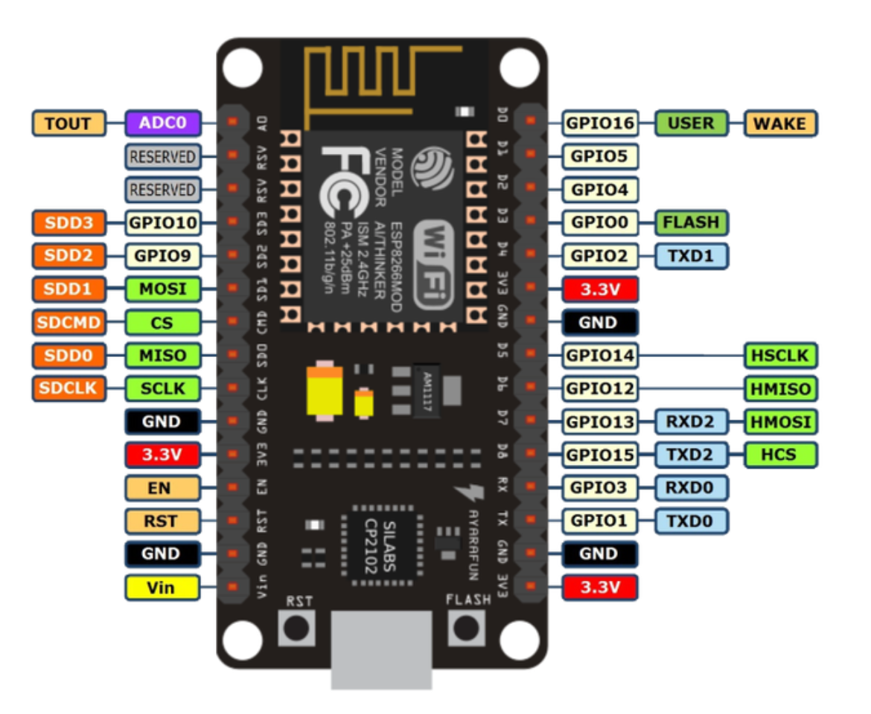

**Figure: NODEMCU**

**NodeMCU** Development board is featured with wifi capability, analog pin, digital pins and serial communication protocols.

To get start with using NodeMCU for IoT applications first we need to know about how to write/download NodeMCU firmware in NodeMCU Development Boards. And before that where this NodeMCU firmware will get as per our requirement.

There is online NodeMCU custom builds available using which we can easily get our custom NodeMCU firmware as per our requirement.

To know more about how to build custom NodeMCU firmware online and download it refer [Getting started with NodeMCU](http://www.electronicwings.com/nodemcu/getting-started-with-nodemcu-using-arduino-ide).

**In addition, some pins have specialized functions:**

The GPIO’s shown in blue box (1, 3, 9, 10) are mostly not used for GPIO purpose on Dev Kit.

ESP8266 is a system on a chip (SoC) design with components like the processor chip. The processor has around 16 GPIO lines, some of which are used internally to interface with other components of the SoC, like flash memory.

Since several lines are used internally within the ESP8266 SoC, we have about 11 GPIO pins remaining for GPIO purpose.

Now again 2 pins out of 11 are generally reserved for RX and TX in order to communicate with a host PC from which compiled object code is downloaded.

Hence finally, this leaves just 9 general purpose I/O pins i.e. D0 to D8.

As shown in above figure of NodeMCU Dev Kit. We can see RX, TX, SD2, SD3 pins are not mostly used as GPIOs since they are used for other internal process. But we can try with SD3 (D12) pin which mostly like to respond for GPIO/PWM/interrupt like functions.

**3.2 SOIL MOISTURE SENSOR:**

This moisture sensor can read the amount of moisture present in the soil surrounding it. It's a low tech sensor, but ideal for monitoring an urban garden, or your pet plant's water level. This is a must have tool for a connected garden. This sensor uses the two probes to pass current through the soil, and then it reads that resistance to get the moisture level. More water makes the soil conduct electricity more easily (less resistance), while dry soil conducts electricity poorly (more resistance). It will be helpful to remind you to water your indoor plants or to monitor the soil moisture in your garden.

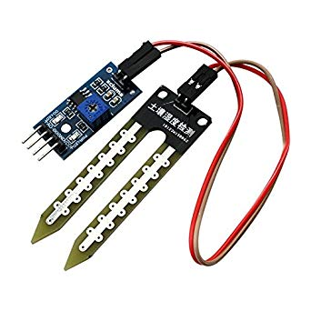

A Chinese built YL-69 sensors (Figure 3.6) come with a ‘middle-man’ circuit which allows to get two outputs: one is an analog readout of the resistance between the sensor’s probes and the second is a digital output (essentially, HIGH or LOW, 5v or 0v) depending on whether the humidity is above or below a threshold which can in turn be adjusted by a built-in POTS. The YL-69 sensor has two pins which need to be wired to be the two pins on the YL-38 Bridge. On the other end of the YL-38 have four pins which represent VCC, GND, D0 and A0. VCC and GND are power pins which should set to 3.3/5V and ground respectively. A0 is an analog output. D0 is a digital output.

**3.3 DHT11 SENSOR:**

The **DHT11** is a basic, ultra low-cost digital temperature and humidity **sensor**. It uses a capacitive humidity **sensor** and a thermistor to measure the surrounding air, and spits out a digital signal on the data pin (no analog input pins needed). Its fairly simple to use, but requires careful timing to grab data.

The **DHT11** calculates relative humidity by measuring the electrical resistance between two electrodes. The humidity **sensing** component of the **DHT11 is** a moisture holding substrate with the electrodes applied to the surface.

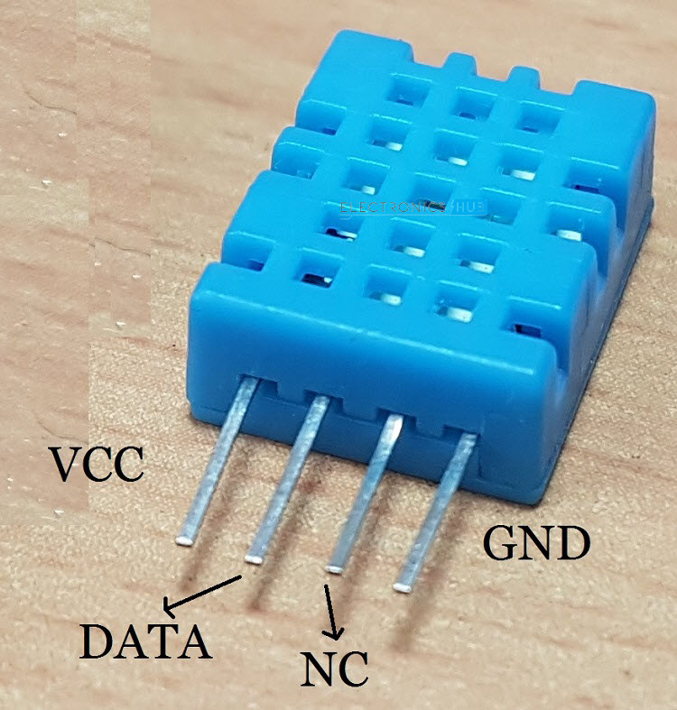

Also the DHT22 sensor has better humidity measuring range, from 0 to 100% with 2-5% **accuracy**, while the **DHT11** humidity range is from 20 to 80% with 5% **accuracy**. There are two specification where the **DHT11** is better than the DHT22.

**3.4 SUBMERSIBLE WATER PUMP:**

A submersible pump (or sub pump, electric submersible pump) is a device which has a hermetically sealed motor close-coupled to the pump body. The whole assembly is submerged in the fluid to be pumped. The main advantage of this type of pump is that it prevents pump cavitation’s, a problem associated with a high elevation difference between pump and the fluid surface. Small DC Submersible water pumps push fluid to the surf ace as opposed to jet pumps having to pull fluids. Submersibles are more efficient ace as opposed to jet pumps having to pull fluids. Submersibles are more efficient than jet pumps. It is usually operated between 3v to 12v. ace as opposed to jet pumps having to pull fluids. Submersibles are more efficient than jet pumps. It is usually operated between 3v to 12v.

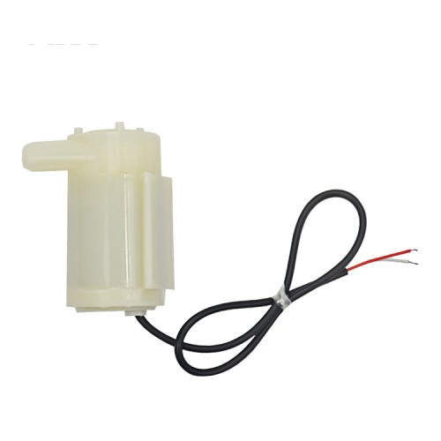

**3.5 RELAY SWITCH:**

Relay is an electromagnetic device which is used to isolate two circuits electrically and connect them magnetically. They are very useful devices and allow one circuit to switch another one while they are completely separate. They are often used to interface an electronic circuit (working at a low voltage) to an electrical circuit which works at very high voltage. For example, a relay can make a 5V DC battery circuit to switch a 230V AC mains circuit. Thus a small sensor circuit can drive, say, a fan or an electric bulb.

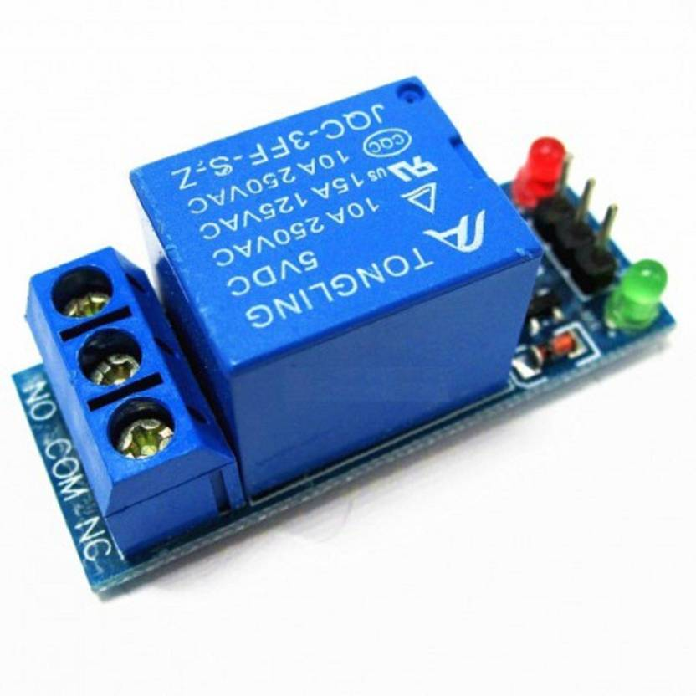

A relay switch can be divided into two parts: input and output. The input section has a coil which generates magnetic field when a small voltage from an electronic circuit is applied to it. This voltage is called the operating voltage. Commonly used relays are available in different configuration of operating voltages like 6V, 9V, 12V, 24V etc. The output section consists of contactors which connect or disconnect mechanically. In a basic relay there are three contactors: normally open (NO), normally closed (NC) and common (COM). At no input state, the COM is connected to NC. When the operating voltage is applied the relay coil gets energized and the COM changes contact to NO.

**Chapter-4**

**WORKING TECHNOLOGY**

**4.1 IoT IN PROPOSED IRRIGATION:**

System In the proposed irrigation system IoT (The Internet of Things) plays a major role. The purpose of the IoT in this system is, it has to share the data to the users. Thus the IoT server is connected with the Wi-Fi module. The information of the soil is transmitted to the Wi-Fi network through the signal conditioning circuit of the various sensors. The IoT technoartista is the open source IoT server through which the signal is shared to the user. The physical information of the soil such as soil moisture, humidity, temperature are send to the Wi-Fi, then it is shared to the user using IoT. it is also shared to the user personal computer with internet connection or smart phone. If the moisture content of the soil is lesser than the reference value then the command from the user device is transmitted to the field section through IoT server then the irrigation system is activated and the water is supplied to the field. Whenever it reaches the span value if moisture content of the soil then the irrigation system is deactivated, that information is also transmitted to the user. This is the chain process of this particular proposed irrigation system.

* 1. **WORKING THINGSPEAK:**

1. This IoT based project has four sections;
2. Firstly Humidity and Temperature Sensor DHT11 senses the Humidity and Temperature Data.
3. Secondly the DHT11 sensor’s data as suitable number in percentage and Celsius scale, and sends it to Wi-Fi Module.
4. Thirdly NodeMCU Wi-Fi Module ESP8266 sends the data to ThingSpeak’s Sever.
5. Finally ThingSpeak analyses the data and shows it in a Graph form. Optional LCD is also used to display the Temperature and Humidity.

**4.3 THINGSPEAK SETUP:**

1. First of all, user needs to Create a Account on ThingSpeak.com, then Sign In and click on Get Started.

2.Now go to the ‘Channels’ menu and click on New Channel option on the same page for further process.

3. Now you will see a form for creating the channel, fill in the Name and Description as per your choice.

4. Now click on ‘API keys’ tab and save the Write and Read API keys, here we are only using Write key. You need to Copy this key in *char *api_key* in the Code.

5. After it, click on ‘Data Import/Export’ and copy the Update Channel Feed GET Request URL .

6. Now user need to open “api.thingspeak.com” using the *httpGet* function with the *postUrl* and then send data using data feed or update request address.

**Chapter-5**

**RESULT**

**5.1 OUTPUT:**

The setup of proposed irrigation system, In which all the components mentioned in the block diagram is connected to measure the real time values of the soil. Implementation of IOT In Smart Irrigation System shows that the real time parameters of the soil that is the soil moisture, Humidity values of the atmosphere. Whenever the soil moisture is below the span of reference value then the signal is transmitted to the user through the Wi-Fi module and the IoT server that signal is received by the user device and the command is sent though the same path and the corrective action is takes place. Temperature and Humidity value of the soil displayed in the user device. Thus after the signal conditioning process the value of humidity and the temperature of the soil is transmitted through the Wi-Fi module of the proposed irrigation system and then it is received to the user device through the open source IoT server technoartista. Then the real time data of the soil and crops such as temperature, humidity of the soil of the crop is transmitted. Thus the humidity and the moisture signal is viewed by the user is in relative to the time. Whenever the signal is deviated from the span of reference value of the proposed irrigation system then the corresponding signal is transmitted to the field section by the user. Thus the received humidity signal is relative to the time, at a particular time the user can monitor the humidity value of the field area. Whenever the humidity value is changes the proposed irrigation system responds the signal which is received from the user.

**5.2 ADVANTAGES:**

1.Privacy/Security

2.Lesser Employment of manual staff or unskilled workers

3.Equipment is costlier

4.Awareness of Indian Farmers for this technology

Complexity : The IOT is a diverse and complex network

* 1. **APPLICATIONS:**

1. Water Conservation

2. Real-Time Data gives

3. Lowered Operation Costs

4. Efficient and Saves Time

5. Increase in productivity

**Chapter-6**

**CONCLUSION & FUTURE SCOPE**

**6.1 CONCLUSION:**

The proposed irrigation system for agricultural purpose can measure the **Soil moisture**, **temperature** of the field and transmits the real time data to the user through the **Wi-Fi** and **IoT** server, if there is any deviation from the span of reference value, then the user can send the command through the IoT server to maintain the set point value of field parameter for a proper irrigation and proposed IoT based irrigation system is better than the recently proposed other irrigation systems.

**6.2 FUTURE SCOPE:**

We can interface LCD screen in order to display the current status of the soil moisture content levels, percentage of water utilized to water the plant, duration of time for which the water pump is ON, etc. We can also show the graphical representation of the moisture content levels in the soil. To improve the efficiency and effectiveness of the system, the following recommendations can be put into consideration. Option of controlling the water pump can be given to the farmer. The farmer may choose to stop the growth of crops or the crops may get damaged due to adverse weather conditions. In such cases farmer may need to stop the system remotely. The idea of using IOT for irrigation can be extended further to other activities in farming such as **cattle management**, **fire detection** and **climate control**. This would minimize human intervention in farming activities.